South Douglas Conservation District 

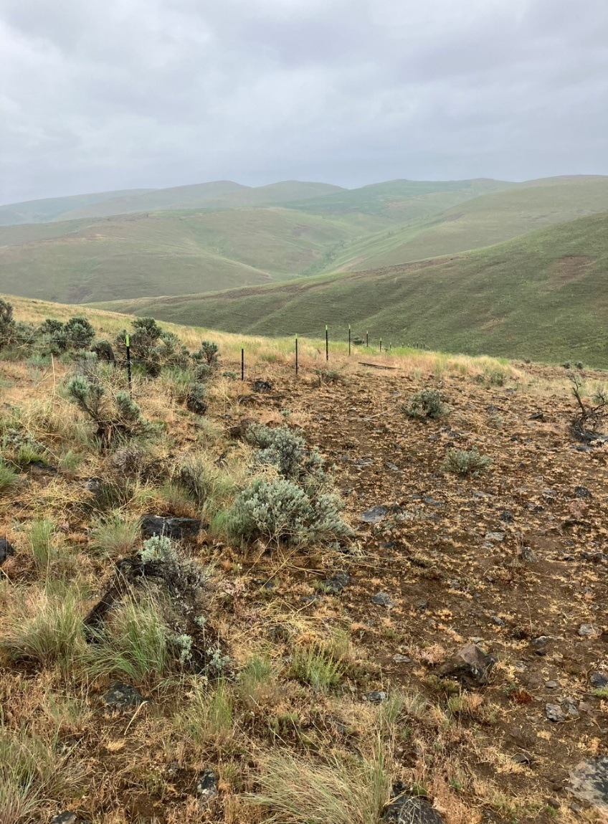

Annual Work Plan for State Fiscal Year 2027 (July 1, 2026-June 30, 2027)

Contact: Carol Cowling, Coordinator, (509) 745-9160, southdouglascd.org

Mission
Maintain and improve natural resources, particularly soil and water, in southern Douglas County through cooperative education, demonstrations, and voluntary participation.

Natural Resource Priorities
- Improve Soil Health: Promote management practices to improve soil health and decrease soil erosion throughout SDCD.
- Forest Health: Develop and implement Firewise plans and projects. Encourage fuels reduction in all terrains.
- Ag Viability: Promote and improve ag viability in SDCD through farmland preservation, cultural and economic systems.
- Irrigation Water Management: Provide technical assistance and cost share for Best Management Practices in SDCD.
- Education: Increase educational opportunities in SDCD for rural and urban residents.
- Range Protection: Maintain and improve productivity of range and shrub steppe.
- Wildlife Habitat: Maintain and improve wildlife habitat in SDCD. Promote pollinator habitat.
- Noxious Weed Control: Reduction and prevention of noxious weed infestations in SDCD.
- Support Post-fire Recovery: Provide technical assistance, education and cost share for “after the fire.”

Program Areas
Natural Resource Priority Program Area: Improve Soil Health

Goal(s): To improve and preserve water quality by preventing soil erosion.

Natural Resource Measurable Result Objective: Reduce erosion by rebuilding dams and terraces within dryland ag fields. The terraces will hold spring run-off and summer storm water in the fields, improving the moisture content of the fields and minimizing the erosion of the soil.

Programmatic Measurable Result Objective: 5 landowners will be contacted to determine the necessity of rebuilding or creating new terraces.

Funding Source(s): WCC Implementation Grant

Activities for FY2027 | Target Dates | Person  Responsible | Time(Days) Required | Estimated Funding | Notes
Support Best Management Practices in dryland grain fields to stop soil erosion and divert water away from farmsteads, orchards, windbreaks and other BMPs (eligible for cost share) | 6/30/27 | CD staff, farmer, Supervisors (Sprauer) | 3 days | 147,030
Soil Testing Cost Share (from Basic Allocation) Soil testing and tissue sampling for private individuals including farmers and gardeners. | 6/30/27 | CD staff | 2 days | 1,000

Natural Resource Priority Program Area: Forest Health

Goal(s): Establish a more fire resistant landscape in Douglas County and promote forest and range health.

Natural Resource Measurable Result Objective: Fuels reduction on forested areas within SDCD (Badger Mountain)

Programmatic Measurable Result Objective: 5 landowners contacted with fire plans.

Funding Source(s): WCC. DNR also funds through their program.

Activities for FY2027 | Target Dates | Person  Responsible | Time(Days) Required | Estimated Funding | Notes
Promote defensible space in both rural and urban communities. Implement Firewise Program in Douglas County practices such as home risk assessments and chipping program. Provide education through newsletters and meetings to encourage fire safety practices. | 6/30/27 | CD staff (Kelly) | 10 days | 2,000
Provide technical assistance and cost share to improve forest and range health and fire resistant landscapes in urban and rural areas. Assist in post fire recovery. | 6/30/27 | CD staff | 10 days | 105,770

Natural Resource Priority Program Area: Irrigation Water Management

Goal(s): To promote water conservation and improve water quality.

Natural Resource Measurable Result Objective: Assist landowners and cooperators in improving water conservation and improve water quality. Investigate new Best Management Practices that may be beneficial to cooperators.

Programmatic Measurable Result Objective: 5 landowners will be contacted to investigate what technical or financial assistance we can provide.

Funding Source(s):

Activities for FY 2027 | Target Dates | Person  Responsible | Time(Days) Required | Estimated Funding | Notes
Contact landowners/cooperators to determine assistance needed, technical and/or financial | 6/30/27 | CD Staff, Supervisors (Morrison) | 5 days | 1,000
Support Best Management Practices in orchards and irrigated fields for water irrigation efficiency projects.(cost share) | 6/30/27 | CD, farmer, NRCS | 5 days | 50,000

Investigate new practices that benefit crop production (netting, shade protection, etc) | 6/30/27 | CD staff, Supervisors (Morrison) | 5 days | 1,000 | Notes

Natural Resource Priority Program Area: Noxious Weed Control

Goal(s): To encourage prevention, monitoring and control of pests through a variety of methods.

Natural Resource Measurable Result Objective: Reduce noxious weeds in invaded areas. Monitor control and prevention of noxious weeds in urban and rural areas.

Programmatic Measurable Result Objective: Five landowners will be contacted to discuss weed control.

Funding Source(s): WCC Implementation Grant

Activities for FY 2027 | Target Dates | Person  Responsible | Time(Days) Required | Estimated Funding | Notes
Assist cooperators with control of pests by integrated pest management (IPM) practices. | 6/30/27 | CD staff  Supervisors | 3 days | 1,000
Investigate the possibility of a nursery for biological control insects. Education program of what is needed before and after the release of bugs. | 6/30/27 | CD Staff  Supervisors (Lesky) | 5 days | 1,000
Technical assistance and cost share for cooperators. Weed mapping and field trips to emphasize weed control (possible pesticide credits) | 6/30/27 | CD staff | 5 days | 1,000
Douglas County Weed Management Area (CWMA) Member of the steering committee to determine projects and funding. | 6/30/27 | Supervisors (Kelly) | As needed | 1,000

Natural Resource Priority Program Area: Voluntary Stewardship Program.

Goal(s): Provide technical assistance to promote conservation practices that project and enhance critical areas and wildlife habitat, while maintaining and improving the long term viability of agriculture.

Natural Resource Measurable Result Objective; Increase the amount of landowners involved in VSP to promote conservation and ag viability

Programmatic Measurable Result Objective: 5 landowners with new VSP projects

Funding Source(s): WCC Implementation Grant, Basic Funding and Plant Sale Income

Activities for FY 2027 | Target Dates | Person  Responsible | Time(Days) Required | Estimated Funding | Notes
Work closely with Foster Creek Conservation District to assist landowners through education and technical assistance to implement Best Management Practices to project critical areas and wildlife habitat. Provide cost share if funding is available. | 6/30/27 | CD Staff  Supervisors (Kelly) | 7 days | 2,000

.

Natural Resource Priority Program Area: Conservation Education and Outreach

Goal(s): Provide conservation education to local schools, farmers and general public

Natural Resource Measurable Result Objective; Increase the number of landowners involved in VSP to promote conservation and ag viability

Programmatic Measurable Result Objective: Three new education programs/events

Funding Source(s): WCC Implementation Grant, Basic Funding and Plant Sale Income

Activities for FY 2027 | Target Dates | Person  Responsible | Time(Days) Required | Estimated Funding | Notes
Quarterly newsletter distributed to all Douglas County mail box holders(16000). Update as needed. Translated to Spanish on the website. | 6/30/27 | CD Staff  Supervisors | 15 days | 18,800
Annual Tree and Shrub Sale – promote use of native and adapted plants for Douglas County. Encourage use of pollinators in rural and urban communities. | 6/30/27 | CD Staff  Supervisors | 7 days | 4,000
Education activities as available – annual meeting, informational meetings, support of school conservation education programs – NCW Envirothon, FFA, Waterville Grade School Douglas Creek project, NCW Fair booth, SDCD website. | 6/30/27 | CD Staff  Supervisors (Grillo) | 14 days | 7,500

Natural Resource Priority Program Area: District Operations

Goal(s): Maintain effective district operations to support the priority programs.

Programmatic Measurable Result Objective; Efficient administration of the district and management of district beyond grant-funded programs. Maintain compliance with legal, financial and reporting requirements.

Funding Source(s): WCC Grants, Basic Funding and Plant Sale Income

Activities for FY 2027 | Target Dates | Person  Responsible | Time(Days) Required | Estimated Funding | Notes
Maintain financial and administrative records in accordance with appliable laws and rules. Tracking of grants as needed, provide board of supervisors with information as needed for the efficient operations of the district. Other administrative duties as required. | 6/30/27 | CD Staff | 625 hours | 19,000

Budget
SDCD 0 budget for the Fiscal Year 2027 (July 1, 2026 – June 30, 2027)

Revenues |  |  |  |  | Expenses
Basic Allotment | 12,500 |  |  |  | Administration |  | 25,000
Douglas County | 2,500 |  |  |  | Cost Share Projects |  | 200,030
WCC Grant Support | 342,000 |  |  |  | Newsletter |  | 18,800
Tree and Shrub Sale | 6,000 |  |  |  | Plant Sale Expense |  | 4,000
Interest Income | 100 |  |  |  | Education Expense |  | 7,500
 | 363,100 |  |  |  | Forest Health |  | 107,770
 |  |  |  |  |  |  | 363,100

